Chapter Three

Memory Management
Memory is a large array of words or bytes, each with its own address in computer system.
Memory is an important resource that must be carefully managed.
A program resides on a disk as a binary executable file. The program must be brought into memory and placed within a process for it to be executed depending on the memory management in use and the process may be moved between disk and memory during its execution.
- Memory management is the functionality of an operating system which handles or manages primary memory.
- Memory management keeps track of each and every memory location either it is allocated to some process or it is free.
- It checks how much memory is to be allocated to processes. It decides which process will get memory at what time.
- It tracks whenever some memory gets freed or unallocated and correspondingly it updates the status. Most computers have memory hierarchy with register, RAM/ROM and non-volatile disk storage, so the operating system responsible to coordinates these memories. the part of the operating system that manages the memory hierarchy is called the memory manager. Its job/role is to efficiently manage memory: keep track of which parts of memory are in use and which parts are not in use. Allocate memory to processes when they need it, and deallocate it and Manages swapping between main memory and disk.
Basic Memory Management
Memory management systems can be divided into two basic classes: those that move processes back and forth between main memory and disk during execution (swapping and paging), and those that do not. Swapping and paging are largely artifacts caused by the lack of sufficient main memory to hold all programs and data at once. If main memory ever gets so large that there is truly enough of it, the arguments in favor of one kind of memory management scheme or another may become obsolete.
Monoprogramming without swapping or paging:
- Here only one program at a time, so entire memory is shared by program and Operating system alone.
- Different ways in which memory can be organized to be shared by one process and Operating system is shown in below diagrams.
- Here requests a program for run, Operating system copies the requested program from disk to memory and executes it.
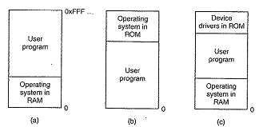
The above figure illustrates different ways of organizing memory between program and operating system
- When the process finishes running, O.S waits for new request from user.
Multiprogramming with fixed partitions:
- In order to enable multiprogramming facility in modern systems, many process needs to be placed in memory. By placing multiple programs in memory, when one process is blocked, another process can be run. So in order to keep N process in memory, here the entire memory is divided in N partitions.
- After partitioning memory, an input queue can be maintained for each partition or for all partitions collectively a single input queue can be maintained.
- When a job gets to head of the queue they are loaded into partition.
- By maintain only one queue for all partitions, the wait time that occurs by maintain input queue for each partition is reduced.
Problems caused by Multiprogramming:
- Multiprogramming introduces two essential problems that must be solved
1. Relocation
2. Protection

RELOCATION PROBLEM:
When a program is run it does not know in advance what location it will be loaded at. Therefore, the program cannot simply generate static addresses (e.g. from jump instructions). Instead, they must be made relative to where the program has been loaded.
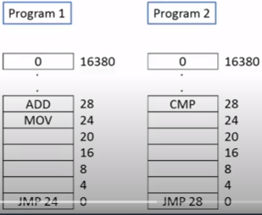
Suppose we are going to execute program1 and program 2 simultaneously, program2 is loaded starting from 16384 over program 1. If you execute the instruction JMP 28 of program 2 then this instruction will jump to 28 of program2 and get instruction CMP, but if you execute the instruction JMP 28 after combination of program 1 and program 2 from the memory, it will jump to 28 of program 1 and got instruction ADD which is wrong. This problem is known as relocation problem
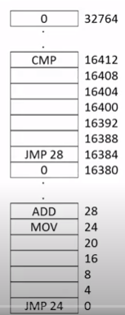
One possible solution is to actually modify the instructions as the program is loaded into memory. To perform relocation during loading like this, the linker must include in the binary program a list or bitmap telling which program addresses to be relocated and which are opcodes, constants, or other items that must not be relocated.
An alternative solution to both the relocation and protection problems, we use two special hardware registers, called the base and limit registers. When a process is scheduled, the base register is loaded with the address of the start of its partition, and the limit register is loaded with the length of the partition. So every memory address generated has base register content added to it before being sent to memory.
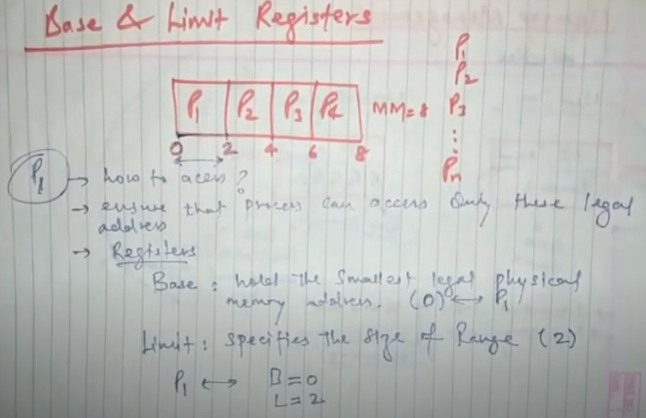
Thus if base register contains value 0 to 2 instruction is effectively turned into a call 0+2 instruction. The hardware protects the base and limit registers to prevent user programs from modifying them. The limit register is loaded with the maximum length of that partition so instruction beyond this limit cannot be accessed.one can access p1 only between 0 and 2
A disadvantage of this scheme is the need to perform an addition and a comparison on every memory reference. Comparisons can be done fast, but additions are slow due to carry
propagation time
PROTECTION PROBLEM:
Once you can have two programs in memory at the same time there is a danger that one program can read or write to the address space of another program. This is obviously dangerous and should be avoided. So the solution for protecting was to divide memory into blocks of 2KB and assign a 4-bit protection code to each block. The PSW(program status word) contains a 4-bit key.
- Any attempt by a running process to access the memory is checked, if PSW matches they are allowed to access else the access are denied.
Swapping
- Swapping is a mechanism in which a process can be swapped temporarily out of main memory to hard-disk and then brought back into memory for continued execution. In batch system, many jobs can be kept in memory to keep CPU busy all time. In time sharing, since there is not enough main memory to hold all active process, excess process must be kept on disk & brought in to run dynamically.
Two general approaches to memory management can be used, depending on the available hardware. The simplest strategy, called swapping, consists of bringing in each process in its entirety, running it for a while, then putting it back on the disk. The other strategy, called virtual memory, allows programs to run even when they are only partially in main memory.
The operation of a swapping system is illustrated in Fig. Initially, only process A is in memory. In fig(c) Then processes B and C are created or swapped in from disk. In Fig. (d) A is swapped out to disk. Then D comes in and B goes out. Finally A comes in again. Since A is now at a different location, addresses contained in it must be relocated, either by software when it is swapped in or (more likely) by hardware during program execution.
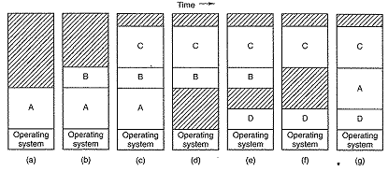
figure depicts, Memory allocation changes and address contained changes as processes come into memory and leaves it. The shaded regions are unused memory. Here the number, location, size of partition vary dynamically, allowing good memory utilization. but it also complicates allocating and deallocating memory, as well as keeping track of it.
Disadvantage: Allocating and De-allocating memory is complex, memory compaction is needed and as data segment grows, problem rises.
When swapping creates multiple holes in memory, it is possible to combine them all into one big one by moving all the processes downward as far as possible. This technique is known as memory compaction.
Memory Management with Bitmaps
When memory is assigned dynamically, the operating system must manage it
With a bitmap, memory is divided up into allocation units, perhaps as small as a few words and perhaps as large as several kilobytes. Corresponding to each allocation unit is a bit in the bitmap, which is 0 if the unit is free and 1 if it is occupied (or vice versa).
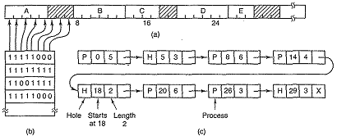
The smaller the allocation unit is chosen, bitmap will be larger or vice versa.
If the allocation unit is chosen large, the bitmap will be smaller, but appreciable memory may be wasted in the last unit of the process if the process size is not an exact multiple of the allocation unit. A bitmap provides a simple way to keep track of memory words in a fixed amount of memory because the size of the bitmap depends only on the size of memory and the size of the allocation unit.
The drawback is searching a bit map for a run is time consuming and slow operation
Memory management with linked list.
- Another way of keeping track of memory is to maintain a linked list of allocated & free memory segment, where a segment is either a process or a hole between two processes.
- Each entry in list specifies a hole (H) or process(P) & the address at which it starts, the length and a pointer to next entry. See figure C
- The segment list is kept sorted by address.
- Advantage is when process terminates or is swapped out, updating list is straightforward.
A terminating process has two neighbours either process or hole leading to 4 combinations as shown in below diagram
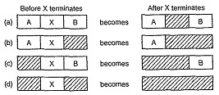
- Several algorithms exists to allocate memory for newly created process if process & holes are kept on a list.
- First fit: Allocate the 1st hole that is big enough to fit for that process.
- Next fit: the same as first fit algorithm, but always start from the last allocated hole
- Best fit: allocate the smallest hole that big enough. Searches entry list and try to find the best hole to minimize internal fragmentation/memory wastage. But slower in working.
- Worst fit: allocate the largest hole, must also search entry list and it leads to memory wastage.
Example given a 5 memory partitions of 100KB, 500KB, 200KB, 300KB and 600KB in order. How would the first-fit, bets-fit and worst-fit algorithms place process of 212KB, 417KB, 112KB &426KB (in order). Which algorithm makes the most efficient use of memory?
VIRTUAL MEMORY:
Many years ago people were first confronted with programs that were too big to fit in the available memory. The solution usually adopted was to split the program into pieces, called overlays. Overlay 0 would start running first. When it was done, it would call another overlay. The overlays were kept on the disk and swapped in and out of memory by the operating system, dynamically, as needed. Although the actual work of swapping overlays in and out was done by the system, the decision of how to split the program into pieces had to be done by the programmer. Splitting up large programs into small, modular pieces was time consuming and boring.
The basic idea behind virtual memory is that the combined size of the program, data, and stack may exceed the amount of physical memory available for it. The operating system keeps those parts of the program currently in use in main memory, and the rest on the disk. For example, a 512-MB program can run on a 256-MB machine by carefully choosing which 256 MB to keep in memory at each instant, with pieces of the program being swapped between disk and memory as needed.
PAGING:
The virtual memory is divided into units called page’s. Physical memory is also divided into units called page frame.
- Virtual address refers to address in virtual memory where program will be placed.
- This entire memory with virtual address is called collectively as virtual address space.
Most virtual memory systems use a technique called paging. Page size always power of 2
In paging, CPU generate logical address, virtual/logical address should convert into physical address. Logical address further divided into 2-page numbers and offset value. Suppose the actual logical address space is 2^{m} and page size is 2^{n}. From this m-n denotes page number and n denotes offset value. example if logical address space is 16-byte memory and page size is 4byte then calculate page numbers and offset value. Page number=4-2 which is 2 and offset= 2,so the first 2 bits represent page numbers and the 2nd 2 bits represent offset. What if LAS=14?
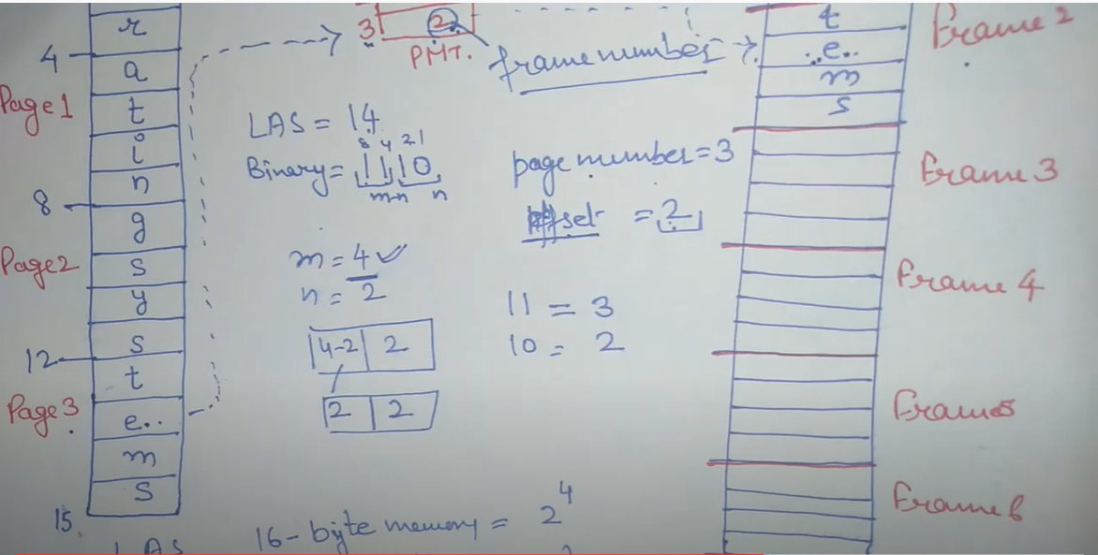

When a program uses an instruction like MOV REG,1000. it does this to copy the contents of memory address 1000 to REG
- If there is no virtual memory, the virtual address just points directly to the physical memory location.
- If there is virtual memory, virtual address is given to MMU(memory management unit) which maps virtual address to physical memory address.
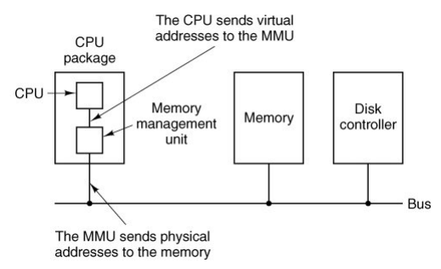
Size of page and page frame are always same
Example, we have a computer that can generate 16-bit addresses, from 0 up to 64K. These are the virtual addresses. This computer, however, has only 32 KB of physical memory, so although 64-KB programs can be written, they cannot be loaded into memory in their entirety and run. A complete copy of a program's memory image, up to 64 KB, must be present on the disk, however, so that pieces can be brought in as needed.
The relation between virtual addresses and physical memory addresses is given by the page table
The virtual address space is divided up into units called pages. The corresponding units in the physical memory are called page frames. The pages and page frames are always the same size. In this example they are 4 KB, but page sizes from 512 bytes to 1 MB have been used in real systems. With 64 KB of virtual address space and 32 KB of physical memory, we get 16 virtual pages and 8 page frames. Transfers between RAM and disk are always in units of a page.
When the program tries to access address 0, for example, using the instruction
MOV REG,0
Virtual address 0 is sent to the MMU. The MMU sees that this virtual address falls in page 0 (0 to 4095), which according to its mapping is page frame 2 (8192 to 12287). So MMU tracks this mapping and outputs address 8192 from where actual execution is done
MOV REG,8192 is effectively transformed into MOV REG,24576
because virtual address 8192 is in virtual page 2 and this page is mapped onto physical page frame 6 (physical addresses 24576 to 28671). As a third example, virtual address 20500 is 20 bytes from the start of virtual page 5 (virtual addresses 20480 to 24575) and maps onto physical address 12288 + 20 = 12308.
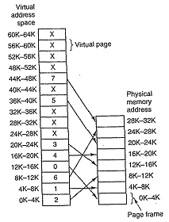
- The above diagram shows relation between virtual address and physical memory address.
- In the above diagram, virtual memory is big and most of its page are not mapped to page frame. So when reference to unmapped location is made, a trap occurs. This condition is called page fault.
- So what operating system does is, it writes little used page frame into disk and fetches the page just referenced into page frame just freed and changes the map and restarts the trapped instruction.
Now let us look inside the MMU to see how it works and why we have chosen to use a page size that is a power of 2. In Fig. 4-9 we see an example of a virtual address, 8196 (0010000000000100 in binary), being mapped using the MMU map of the above Fig. The incoming 16- bit virtual address is split into a 4-bit page number and a 12-bit offset. With 4 bits for the page number, we can have 16 pages, and with 12 bits for the offset, we can address all 4096 bytes within a page
Figure 4-9. The internal operation of the MMU with 16 4-KB pages.
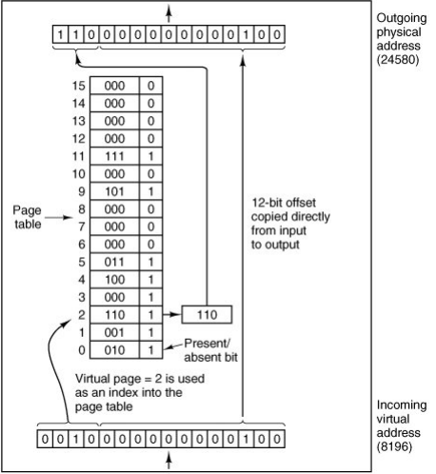
The page number is used as an index into the page table, yielding the number of the page frame corresponding to that virtual page. If the present/absent bit is 0, a trap to the operating system is caused. If the bit is 1, the page frame number found in the page table is copied to the high-order 3 bits of the output register, along with the 12-bit offset, which is copied unmodified from the incoming virtual address. Together they form a 15-bit physical address. The output register is then put onto the memory bus as the physical memory address.

PAGE TABLE:
- Purpose of page table is to map virtual page into page frame.
- Virtual address is split into virtual page number (the higher order bits) and offset (the lower order bits). For example, with a 16-bit address and a 4-KB page size, the upper 4 bits could specify one of the 16 virtual pages and the lower 12 bits would then specify the byte offset (0 to 4095) within the selected page
- Virtual page number is used as index into page table to find entry for that virtual page.
- For that page table entry, the corresponding page frame number is found.
- This Page frame number is appended to high order end of offset. Thus forming a physical address.
Issues: issues must be faced
- Page table can be extremely large, so mapping would take considerably long time. So by some mechanism there is a need to make mapping faster.The virtual-to-physical mapping must be done on every memory reference. The need for large, fast page mapping is a significant constraint on the way computers are built.
The simplest design is to have a single page table consisting of an array of fast hardware registers, with one entry for each virtual page, indexed by virtual page number
When a process is started up, the operating system loads the registers with the process' page table, taken from a copy kept in main memory. During process execution, no more memory references are needed for the page table.
The advantages of this method are that it is straightforward and requires no memory references during mapping.
Disadvantages of page table:
- It is potentially expensive (if the page table is large)
- Since page table itself is large it consumes memory
- Also, having to load the full-page table at every context switch hurts performance
- The page table can be entirely in main memory. All the hardware needs a single register that points to the start of the page table. This design allows the memory map to be changed at a context switch by reloading one register.
- Requiring one or more memory references to read page table entries during the execution of each instruction. For this reason, this approach is rarely used
Remedy:
- To get around the problem of having to store huge page tables in memory all the time, many computers use a multilevel page table.
- Multilevel Paging is a paging scheme which consist of two or more levels of page tables in a hierarchical manner. It is also known as hierarchical paging. The entries of the level 1 page table are pointers to a level 2 page table and entries of the level 2 page tables are pointers to a level 3 page table and so on
The need for multilevel paging arises when-
- The size of page table is greater than the frame size.
- As a result, the page table cannot be stored in a single frame in main memory.

In multilevel paging,
- The page table having size greater than the frame size is divided into several parts.
- The pages of page table are then stored in different frames of the main memory.
- To keep track of the frames storing the pages of the divided page table, another page table is maintained.
- Multilevel paging is done till the level is reached where the entire page table can be stored in a single frame.
Consider a system using paging scheme where-
- Logical Address Space = 4 GB
- Physical Address Space = 16 TB
- Page size = 4 KB
Now, let us find how many levels of page table will be required.

Number of Bits in Physical Address-
Size of main memory= Physical Address Space
= 16 TB = 2⁴⁴ B. Thus, Number of bits in physical address = 44 bits

Number of Frames in Main Memory-
Number of frames in main memory= Size of main memory / Frame size
16 TB / 4 KB= 2³² frames. Thus, Number of bits in frame number = 32 bits

Number of Bits in Page Offset-
We have, Page size= 4 KB
= 2¹² B Thus, Number of bits in page offset = 12 bits
Alternatively,
Number of bits in page offset = Number of bits in physical address – Number of bits in frame number
= 44 bits – 32 bits
= 12 bits
So, Physical address is-
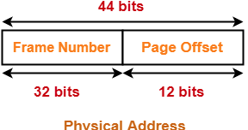

Number of Pages of Process-
Number of pages the process is divided = Process size / Page size
4 GB / 4 KB= 2²⁰ pages

Inner Page Table Size-
Inner page table keeps track of the frames storing the pages of process.
Inner Page table size = Number of entries in inner page table x Page table entry size
= Number of pages the process is divided x Number of bits in frame number
= 2²⁰ x 32 bits= 2²⁰ x 4 bytes= 4 MB
Now, we can observe-
- The size of inner page table is greater than the frame size (4 KB).
- Thus, inner page table cannot be stored in a single frame.
- So, inner page table has to be divided into pages.

Number of Pages of Inner Page Table-
Number of pages the inner page table is divided = Inner page table size / Page size
4 MB / 4 KB= 2¹⁰ pages
Now, these 2¹⁰ pages of inner page table are stored in different frames of the main memory.

Number of Page Table Entries in One Page of Inner Page Table-
Number of page table entries in one page of inner page table= Page size / Page table entry size
= Page size / Number of bits in frame number= 4 KB / 32 bits
= 4 KB / 4 B= 2¹⁰

Number of Bits Required to Search an Entry in One Page of Inner Page Table-
One page of inner page table contains 2¹⁰ entries.
Thus, Number of bits required to search a particular entry in one page of inner page table = 10 bits

Outer Page Table Size-
Outer page table is required to keep track of the frames storing the pages of inner page table.
Outer Page table size= Number of entries in outer page table x Page table entry size
= Number of pages the inner page table is divided x Number of bits in frame number
= 2¹⁰ x 32 bits= 2¹⁰ x 4 bytes= 4 KB
Now, we can observe-
- The size of outer page table is same as frame size (4 KB).
- Thus, outer page table can be stored in a single frame.
- So, for given system, we will have two levels of page table.
- Page Table Base Register (PTBR) will store the base address of the outer page table.

Number of Bits Required to Search an Entry in Outer Page Table-
Outer page table contains 2¹⁰ entries.
Thus, Number of bits required to search a particular entry in outer page table = 10 bits
The paging system will look like as shown below-
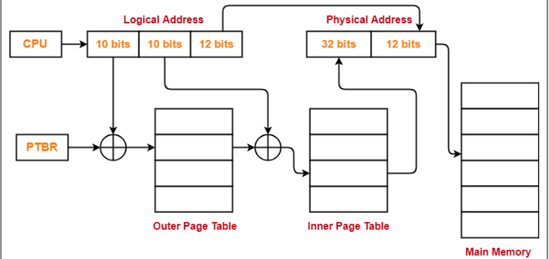
The secret to the multilevel page table method is to avoid keeping all the page tables in memory all the time. In particular, those that are not needed should not be kept around.
Disadvantages. Extra memory references to access address translation tables can slow programs down by a factor of two or more.
The solution that has been devised is to equip computers with a small hardware device, called a TLB (Translation Lookaside Buffer) or sometimes an associative memory. It is used for rapidly mapping virtual addresses to physical addresses without going through the page table. It is usually inside the MMU and consists of a small number of entries, eight in this example, but rarely more than 64. Each entry contains information about one page, including the virtual page number, a bit that is set when the page is modified, the protection code (RWX permission), and the physical page frame in which the page is loaded.
These fields have a one-to-one correspondence with the fields in the page table. Another bit indicates whether the entry is valid (i.e., in use) or not.
A TLB to speed up paging
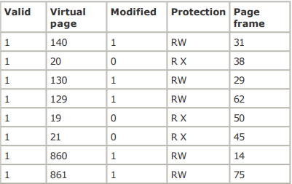
When virtual page number is not in TLB, MMU detects that a miss has occurred & does page table lookup
Page Replacement Algorithms
When a page fault occurs, the operating system has to choose a page to remove from memory to make room/disk for the page that has to be brought in. system performance is much better if a page that is not heavily used is chosen. If a heavily used page is removed, it will probably have to be brought back in quickly, resulting in extra overhead. Much work has been done on the subject of page replacement algorithms, both theoretical and experimental. How to use local page replacement algorithm or the Global page replacement algorithm
- If page fault occurs and shared page replacement algorithm finds least recently used page in the set of pages assigned for that particular process alone and replaces the least used page, then this phenomenon is called Local page replacement algorithm.
- If page fault occurs and shared page replacement algorithm finds least recently used page among the set of pages assigned for all process and replaces the least used page, then this phenomenon is called Global page replacement algorithm
Reading Assignment describe some of the most important Page Replacement algorithms
SEGMENTATION:
The virtual memory is one-dimensional because the virtual addresses go from 0 to some maximum address, one address after another. For many problems, having two or more separate virtual address spaces may be much better than having only one. What is really needed is a way of freeing the programmer from having to manage the expanding and shrinking tables, in the same way that virtual memory eliminates the worry of organizing the program into overlays. A straightforward and extremely general solution is to provide the machine with many independent address spaces, called segments
- Each segment consists of linear sequence of address from 0 to some maximum.
- Unlike paging, here different segments may have different length.
- And segment length may change i.e. grow or shrink independently during execution as each segment constitutes a separate address.
- In-order to specify an address among segment, two part addressing mechanism is used,
the first part (i.e. Segment number), segment number denotes the segment within which the address could be found and the second part (i.e. the address that follows segment number) denotes the exact address within the segment.
Diagram illustrating how a segment memory allows each table to grow or shrink independently is shown in below diagram
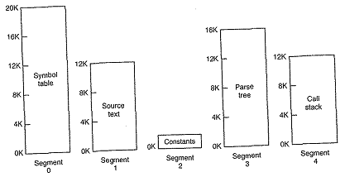
Advantages:
- Sharing of procedures between programmers is facilitated as each segment forms a logical entity of which each programmer is aware and use.
- Different segments can have different kinds of protection
- Simplifying the handling of data structures that are growing or shrinking.
Disadvantage:
- Segmentation also introduces the phenomenon called checker boarding or external fragmentation as shown in below diagram from fig (a) to fig (d).
Remedy:
- Memory compaction technique is needed to get rid of external fragmentation.
- The below diagram illustrating external fragmentation phenomenon shows how the memory compaction technique has been done resulting in fig (e).
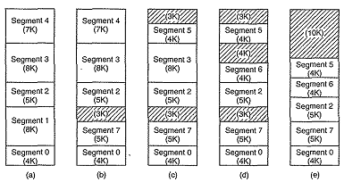

Fragmentation
As processes are loaded and removed from memory, the free memory space is broken into little pieces. It happens after sometimes that processes cannot be allocated to memory blocks considering their small size and memory blocks remains unused. This problem is known as Fragmentation.
Fragmentation is of two types
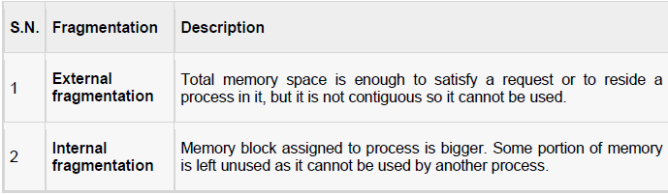
External fragmentation can be reduced by compaction or shuffle memory contents to place all free memory together in one large block.

